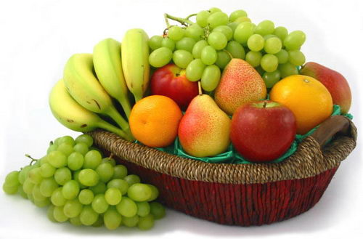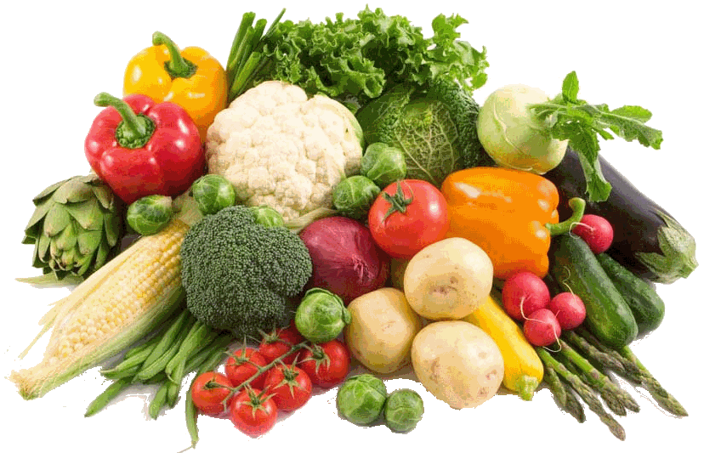

**Purchase your Good Food Box at the Marmora Pentecostal Church**

**Where: 53 Madoc St. Marmora, Wednesdays 10am-2pm.**

**Payment: Usually due by the 1st Wednesday of the month All sales are CASH only.**

**Pick-up: Usually the 3rd Wednesday of each month between 3-5pm.**

**For more information: Call Elaine at: 613-472-3219 / Visit** [**www.mpchurch.ca**](http://www.mpchurch.ca)

**Brochure also available**