

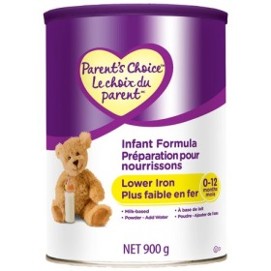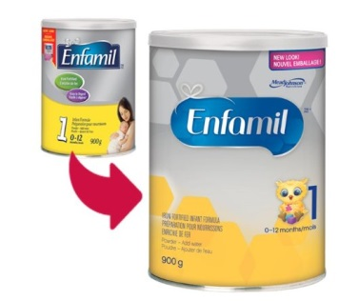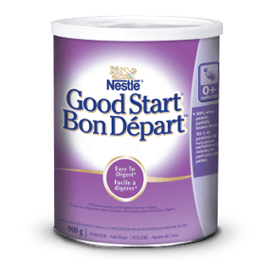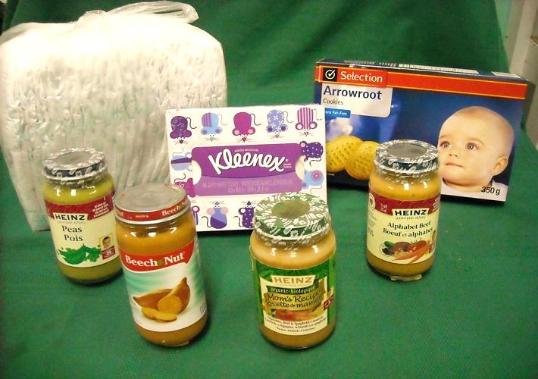

**Purchase your Good Baby Box at the Marmora Pentecostal Church**

**Where: 53 Madoc St. Marmora, Wednesdays 10am-2pm.**

**Payment: All sales are CASH only.**

**For more information: Call Elaine at: 613-472-3219 / Visit** [**www.mpchurch.ca**](http://www.mpchurch.ca)

**Brochure also available**